Add to Cart with output()
In this exercise, you will
- Learn how to pass data from child to parent component.

- Continue from previous store application. Make sure that the Terminal Server is there . Run the web project.
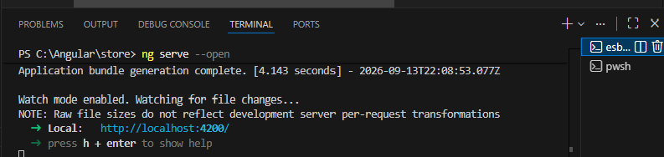

- Change the products-grid.ts
import { Component, signal, computed } from '@angular/core';
import { ProductCard } from '../product-card/product-card';
import { Product } from '../product';
import {MatIconModule} from '@angular/material/icon';

import {FormsModule} from '@angular/forms';
import {MatInputModule} from '@angular/material/input';
import {MatFormFieldModule} from '@angular/material/form-field';

@Component({
selector: 'app-products-grid',
imports: [ProductCard, MatIconModule, MatFormFieldModule, MatInputModule, FormsModule, MatIconModule],
templateUrl: './products-grid.html',
styleUrl: './products-grid.scss',
})
export class ProductsGrid {
protected readonly searchTerm = signal('');

protected readonly products = signal<Product[]>([
{
id: 1,
name: "Durian",
description: "The king of fruit",
price: 35.0,
originalPrice: 50.0,
},
{
id: 2,
name: "Nenas",
description: "Unique fruit from Johor",
price: 8.0,
},
{
id: 3,
name: "Dokong",
description: "Imported fruit from Thailand",
price: 12.0,
}
]
);

protected readonly filteredProducts = computed(()=>{
const term = this.searchTerm().toLocaleLowerCase().trim();
if(!term) return this.products();
return this.products().filter(p=>p.name.toLocaleLowerCase().includes(term)||
p.description.toLocaleLowerCase().includes(term));
})
protected clearSearch():void{
this.searchTerm.set('');
}

protected trimSearch(): void{
this.searchTerm.update(v=>v.trim())
}

protected handleSelection(product: Product) {
console.log(product.name);
}
}

- Change the products.grid.htm
<div class="products-container">
<mat-form-field appearance="outline" class="search-field">
<mat-label>Search Product</mat-label>
<input matInput [(ngModel)]="searchTerm" placeholder="e.g Fruit name" />
</mat-form-field>

<p class="searchPreview">
Search Term: {{ searchTerm() }}
</p>
<div class="products-grid">
@for (product of filteredProducts(); track product.id){
<app-product-card [product]="product"
(itemSelected)="handleSelection($event)"/>
}@empty {
<div class="empty-state">
<mat-icon>inventory_2</mat-icon>
<h3>No products match your search</h3>
<p>Check back later for new arrivals!</p>
</div>
}
</div>
</div>
- Change the products.card.ts
import { Component, input, output } from '@angular/core';
import { MatCardModule } from '@angular/material/card';
import { MatAnchor } from '@angular/material/button';
import { Product } from '../product'
@Component({
selector: 'app-product-card',
imports: [MatCardModule, MatAnchor],
templateUrl: './product-card.html',
styleUrl: './product-card.scss',
})
export class ProductCard {
readonly product = input.required<Product>()
readonly addButtonLabel = input('Add to Cart');

readonly itemSelected = output<Product>();

sendNotification() {
this.itemSelected.emit(this.product());
}
}

- Change the products.card.html
<mat-card class="product-card">
<mat-card-header>
<mat-card-title>{{ product().name }}</mat-card-title>
</mat-card-header>

@if (product().originalPrice){
<span class="sale-badge">On Sale</span>

<p class="price-low">
<span class="original-price">{{ product().originalPrice}}</span>
<br/>
<span class="current-price">{{ product().price}}</span>
</p>
}
@else {
<p class="price-low">
<span class="current-price">{{ product().price}}</span>
</p>
}
<mat-card-content>
<p>{{ product().description}}</p>
</mat-card-content>

<mat-card-actions>
<button matButton (click)="sendNotification()">{{ addButtonLabel() }}</button>
</mat-card-actions>
</mat-card>
- Save All
- In the web browser, press F12, select “Console”
- Try Add Durian and Nenas
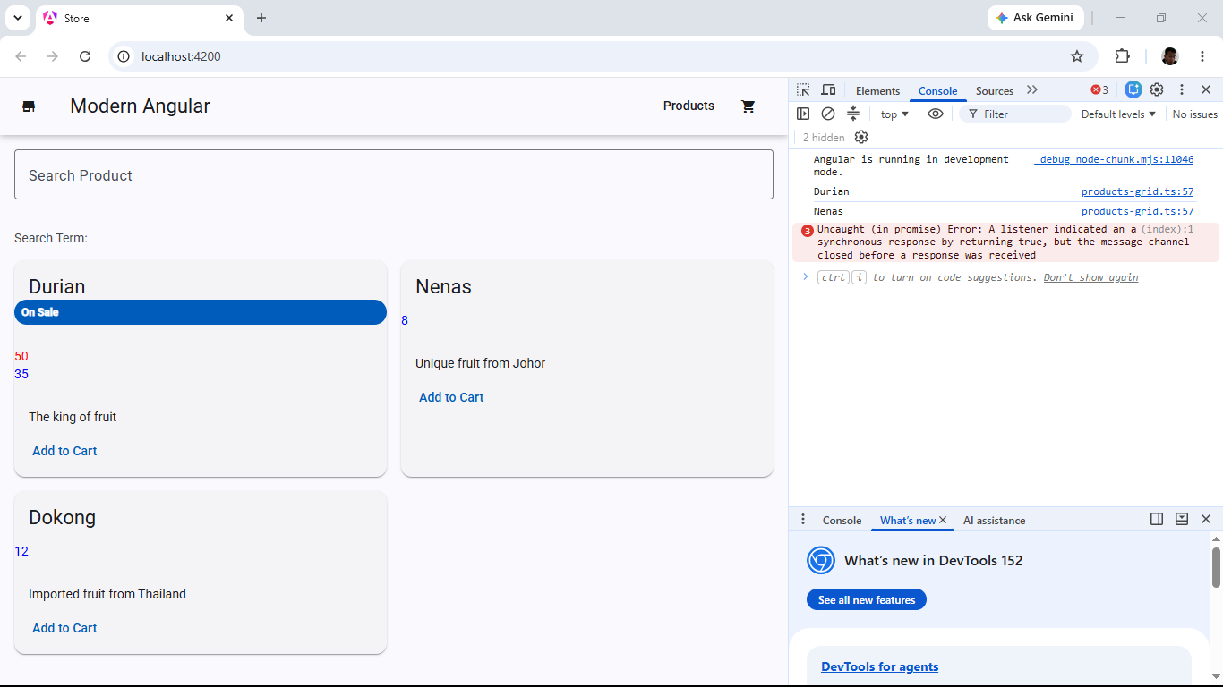
- Close VS Code

- Backup/Zip the application as store(Ex15).7z

